**Introducción a Sistemas Distribuidos**

**Trabajo Práctico Grupal**

**Diseño y configuración sobre una topología de red**

**Grupo 3**

**Integrantes:**

81052 – Cesar Leguizamon ([fabi1816@gmail.com](mailto:david.mdq89@gmail.com))

89636 – Agostina Kodelia ([ankodelia@gmail.com](mailto:ankodelia@gmail.com))

89762 – Florencia Tristant ([flotristant@gmail.com](mailto:flotristant@gmail.com))

90110 – David Marcos ([david.mdq89@gmail.com](mailto:david.mdq89@gmail.com))

90762 – Gabriel Ostrowsky ([gaby.ostro@gmail.com](mailto:gaby.ostro@gmail.com))

**Indice**

1. Subnetting ------------------------------------------------------- 3
2. Fragmentación de la red ------------------------------------- 4
3. Diagrama de las sedes --------------------------------------- 5
4. Configuración IP de routers, servers, hosts y dns ---- 6
5. Ruteo -------------------------------------------------------------- 7

5.1 Ruteo estático – Rutas principales ------------------- 7

5.2 Ruteo dinámico ------------------------------------------- 11

1. Túneles GRE -------------------------------------------------- 13
2. Frame Relay --------------------------------------------------- 15
3. VRRP (Virtual Router Redundancy Protocol) --------- 18
4. DNS -------------------------------------------------------------- 21
5. **Subnetting**

A partir de la topología entregada y el espacio de direccionamiento asignado se procedió a realizar el subnetting de la red. La resolución de direcciones asignadas se realizó siguiendo la RFC 950. El espacio de direccionamiento asignado a cada subred es el que se muestra en la siguiente tabla:

|  |  |  |  |  |  |
| --- | --- | --- | --- | --- | --- |
| **Red** | **Marca** | **Routers que la forman** | **Direcciones necesarias** | **Mascara IP** | **Direccion de red IP** |
| A | Trek | R1-R2-R3-R4 | 211 | /24 | 10.118.5.0 |
| B1 | Coluer | R1-R12 (FrameRelay) | 4 | /30 | 172.143.0.64 |
| B2 | Bianchi | R1-R13 (FrameRelay) | 4 | /30 | 172.143.0.68 |
| B3 | Yeti | R12-R13 (FrameRelay) | 4 | /30 | 172.143.0.72 |
| C | Specialized | R3-R4-R5 | 151 | /24 | 192.168.71.0 |
| D | Pinarello | R5-Rint (cloud) | 4 | /30 | 133.143.1.0 |
| E | Cube | R8-Rint (cloud) | 4 | /30 | 133.143.1.4 |
| F | Fuji | R16-Rint (cloud) | 4 | /30 | 133.143.1.8 |
| G | GT | R6-R7 | 29 | /27 | 10.19.3.32 |
| H | Lapierre | R7-R8-R9-R10 | 15 | /28 | 10.19.3.128 |
| I | Raleigh | R2-R6 | 4 | /30 | 10.19.3.0 |
| J | BH | R10-R11-R12 | 103 | /25 | 10.19.2.0 |
| K | MMR | R11-R13 | 4 | /30 | 10.19.3.4 |
| L | Cannondale | R9-R10-R11 | 22 | /27 | 10.19.3.64 |
| M | Scott | R13-R14 | 29 | /27 | 10.19.3.96 |
| N | Giant | R9 | 37 | /26 | 10.47.1.128 |
| Ñ | Orbea | R14-R15-R16 | 250 | /24 | 10.47.2.0 |
| O | Kona | R15.1 | 7 | /29 | 10.19.3.144 |
| P | Merida | R15.2 | 13 | /28 | 10.19.3.16 |
| Q | Conor | GRE - R5-R8 | 4 | /30 | 10.19.3.8 |
| R | Marin | GRE - R16-R8 | 4 | /30 | 10.19.3.12 |
| S | Ghost | GRE - R5-R16 | 4 | /30 | 10.19.3.152 |

1. **Fragmentación de la red**

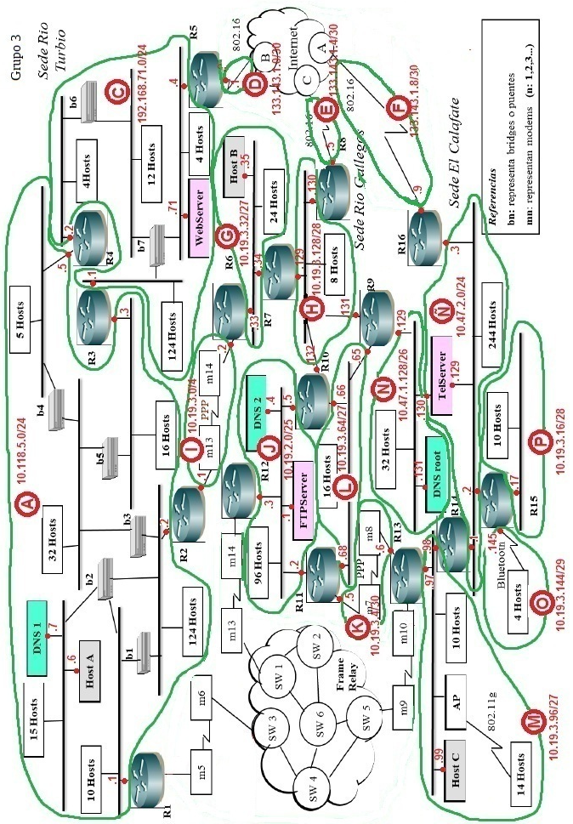

1. **Diagrama de las sedes**

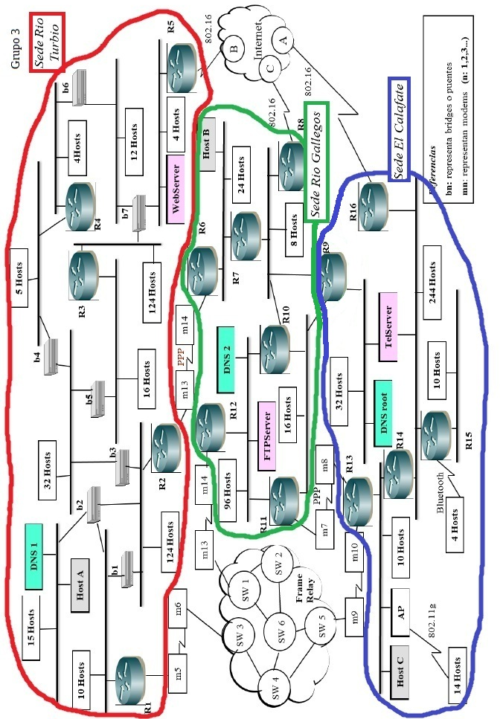

1. **Configuración IP de routers, servers, hosts y dns**

|  |  |  |  |  |
| --- | --- | --- | --- | --- |
| **Router** | **(Red )IP** | | | |
| **R1** | (A) 10.118.5.1 | (B1) 172.143.0.65 | (B2) 172.143.0.69 |  |
| **R2** | (A) 10.118.5.2 | (I) 10.19.3.1 |  |  |
| **R3** | (A) 10.118.5.3 | (C) 192.168.71.1 |  |  |
| **R4** | (A) 10.118.5.4 | (C) 192.168.71.2 |  |  |
| **R virtual 3-4** | (A) 10.118.5.5 | (C) 192.168.71.3 |  |  |
| **R5** | (C) 192.168.71.4 | (D) 133.143.1.1 | (Q) 10.19.3.9 (T-10) | (S) 10.19.3.153 (T-20) |
| **R6** | (G) 10.19.3.33 | (I) 10.19.3.2 |  |  |
| **R7** | (G) 10.19.3.34 | (H) 10.19.3.129 |  |  |
| **R8** | (E) 133.143.1.5 | (H) 10.19.3.130 | (Q) 10.19.3.10 (T-40) | (R) 10.19.3.13 (T-50) |
| **R9** | (H) 10.19.3.131 | (L) 10.19.3.65 | (N) 10.47.1.129 |  |
| **R10** | (H) 10.19.3.132 | (J) 10.19.2.5 | (L) 10.19.3.66 |  |
| **R virtual 9-10** | (H) 10.19.3.133 | (L) 10.19.3.67 |  |  |
| **R11** | *(J) 10.19.2.2* | (K) 10.19.3.5 | (L) 10.19.3.68 |  |
| **R12** | (B1) 172.143.0.66 | (J) 10.19.2.3 | (B3) 172.143.0.73 |  |
| **R13** | (B2) 172.143.0.70 | (K) 10.19.3.6 | (M) 10.19.3.97 | (B3) 172.143.0.74 |
| **R14** | (M) 10.19.3.98 | (Ñ) 10.47.2.1 |  |  |
| **R15** | (Ñ) 10.47.2.2 | (O) 10.19.3.145 | (P) 10.19.3.17 |  |
| **R16** | (F) 133.143.1.9 | (Ñ) 10.47.2.3 | (R) 10.19.3.14 (T-80) | (S) 10.19.3.154 (T-70) |
| **R Internet** | (D) 133.143.1.2 | (E) 133.143.1.6 | (F) 133.143.1.10 |  |
| **HostA** | (A) 10.118.5.6 |  |  |  |
| **HosB** | (G) 10.19.3.35 |  |  |  |
| **HostC** | (M) 10.19.3.99 |  |  |  |
| **TelServer** | (N) 10.47.1.130 | (Ñ) 10.47.2.129 |  |  |
| **FTP Server** | (J) 10.19.2.1 |  |  |  |
| **WebServer** | (C) 192.168.71.71 |  |  |  |
| **DNS root** | (N) 10.47.1.131 |  |  |  |
| **DNS 1** | (A) 10.118.5.7 |  |  |  |
| **DNS 2** | (J) 10.19.2.4 |  |  |  |

1. **Ruteo**

Aquí se observará los diferentes tipos de ruteos aplicados a cada parte de la red. En el caso de ruteo estático, se muestran las tablas de ruteo de los routers en cuestión. En el caso de ruteo dinámico, se da una breve explicación del funcionamiento del protocolo de ruteo utilizado y los comandos necesarios para configurar al mismo.

**5.1 Ruteo estático – Rutas principales**

**R1**

|  |  |  |  |
| --- | --- | --- | --- |
| **Red** | **Dirección de red** | **Máscara** | **Next Hop** |
| B3 | 172.143.0.72 | 255.255.255.252 | 172.143.0.70 |
| C | 192.168.71.0 | 255.255.255.0 | 10.118.5.5 |
| G | 10.19.3.32 | 255.255.255.224 | 10.118.5.2 |
| H | 10.19.3.128 | 255.255.255.192 | 172.143.0.66 |
| I | 10.19.3.0 | 255.255.255.252 | 10.118.5.2 |
| J | 10.19.2.0 | 255.255.255.128 | 172.143.0.66 |
| K | 10.19.3.4 | 255.255.255.252 | 172.143.0.70 |
| L | 10.19.3.64 | 255.255.255.224 | 172.143.0.66 |
| M | 10.19.3.96 | 255.255.255.224 | 172.143.0.70 |
| N | 10.47.1.128 | 255.255.255.192 | 172.143.0.66 |
| Ñ | 10.47.2.0 | 255.255.255.0 | 172.143.0.70 |
| O | 10.19.3.144 | 255.255.255.248 | 172.143.0.70 |
| P | 10.19.3.16 | 255.255.255.240 | 172.143.0.70 |

**R2**

|  |  |  |  |  |
| --- | --- | --- | --- | --- |
| **Red** | **Dirección de red** | **Máscara** | | **Next Hop** |
| B1 | 172.143.0.64 | | 255.255.255.252 | 10.118.5.1 |
| B2 | 172.143.0.68 | | 255.255.255.252 | 10.118.5.1 |
| B3 | 172.143.0.72 | | 255.255.255.252 | 10.118.5.1 |
| C | 192.168.71.0 | | 255.255.255.0 | 10.118.5.5 |
| G | 10.19.3.32 | | 255.255.255.224 | 10.19.3.2 |
| H | 10.19.3.128 | | 255.255.255.192 | 10.19.3.2 |
| I | 10.19.3.0 | | 255.255.255.252 | 10.118.5.2 |
| J | 10.19.2.0 | | 255.255.255.128 | 10.118.5.1 |
| K | 10.19.3.4 | | 255.255.255.252 | 10.118.5.1 |
| L | 10.19.3.64 | | 255.255.255.224 | 10.19.3.2 |
| M | 10.19.3.96 | | 255.255.255.224 | 10.118.5.1 |
| N | 10.47.1.128 | | 255.255.255.192 | 10.19.3.2 |
| Ñ | 10.47.2.0 | | 255.255.255.0 | 10.118.5.1 |
| O | 10.19.3.144 | | 255.255.255.248 | 10.118.5.1 |
| P | 10.19.3.16 | | 255.255.255.240 | 10.118.5.1 |

**R3**

|  |  |  |  |
| --- | --- | --- | --- |
| **Red** | **Dirección de red** | **Máscara** | **Next Hop** |
| B1 | 172.143.0.64 | 255.255.255.252 | 10.118.5.1 |
| B2 | 172.143.0.68 | 255.255.255.252 | 10.118.5.1 |
| B3 | 172.143.0.72 | 255.255.255.252 | 10.118.5.1 |
| G | 10.19.3.32 | 255.255.255.224 | 10.118.5.2 |
| H | 10.19.3.128 | 255.255.255.192 | 10.118.5.1 |
| I | 10.19.3.0 | 255.255.255.252 | 10.118.5.2 |
| J | 10.19.2.0 | 255.255.255.128 | 10.118.5.1 |
| K | 10.19.3.4 | 255.255.255.252 | 10.118.5.1 |
| L | 10.19.3.64 | 255.255.255.224 | 10.118.5.1 |
| M | 10.19.3.96 | 255.255.255.224 | 10.118.5.1 |
| N | 10.47.1.128 | 255.255.255.192 | 10.118.5.1 |
| Ñ | 10.47.2.0 | 255.255.255.0 | 10.118.5.1 |
| O | 10.19.3.144 | 255.255.255.248 | 10.118.5.1 |
| P | 10.19.3.16 | 255.255.255.240 | 10.118.5.1 |

**R4**

|  |  |  |  |
| --- | --- | --- | --- |
| **Red** | **Dirección de red** | **Máscara** | **Next Hop** |
| B1 | 172.143.0.64 | 255.255.255.252 | 10.118.5.1 |
| B2 | 172.143.0.68 | 255.255.255.252 | 10.118.5.1 |
| B3 | 172.143.0.72 | 255.255.255.252 | 10.118.5.1 |
| G | 10.19.3.32 | 255.255.255.224 | 10.118.5.2 |
| H | 10.19.3.128 | 255.255.255.192 | 10.118.5.1 |
| I | 10.19.3.0 | 255.255.255.252 | 10.118.5.2 |
| J | 10.19.2.0 | 255.255.255.128 | 10.118.5.1 |
| K | 10.19.3.4 | 255.255.255.252 | 10.118.5.1 |
| L | 10.19.3.64 | 255.255.255.224 | 10.118.5.1 |
| M | 10.19.3.96 | 255.255.255.224 | 10.118.5.1 |
| N | 10.47.1.128 | 255.255.255.192 | 10.118.5.1 |
| Ñ | 10.47.2.0 | 255.255.255.0 | 10.118.5.1 |
| O | 10.19.3.144 | 255.255.255.248 | 10.118.5.1 |
| P | 10.19.3.16 | 255.255.255.240 | 10.118.5.1 |

**R5**

|  |  |  |  |
| --- | --- | --- | --- |
| **Red** | **Dirección de red** | **Máscara** | **Next Hop** |
| A | 10.118.5.0 | 255.255.255.0 | 192.168.71.3 |
| B1 | 172.143.0.64 | 255.255.255.252 | 192.168.71.3 |
| B2 | 172.143.0.68 | 255.255.255.252 | 192.168.71.3 |
| B3 | 172.143.0.72 | 255.255.255.252 | 192.168.71.3 |
| G | 10.19.3.32 | 255.255.255.224 | 192.168.71.3 |
| H | 10.19.3.128 | 255.255.255.192 | 10.19.3.10 |
| I | 10.19.3.0 | 255.255.255.252 | 192.168.71.3 |
| J | 10.19.2.0 | 255.255.255.128 | 192.168.71.3 |
| K | 10.19.3.4 | 255.255.255.252 | 192.168.71.3 |
| L | 10.19.3.64 | 255.255.255.224 | 10.19.3.10 |
| M | 10.19.3.96 | 255.255.255.224 | 192.168.71.3 |
| N | 10.47.1.128 | 255.255.255.192 | 10.19.3.10 |
| Ñ | 10.47.2.0 | 255.255.255.0 | 10.19.3.154 |
| O | 10.19.3.144 | 255.255.255.248 | 10.19.3.154 |
| P | 10.19.3.16 | 255.255.255.240 | 10.19.3.154 |

**R9**

|  |  |  |  |
| --- | --- | --- | --- |
| **Red** | **Dirección de red** | **Máscara** | **Next Hop** |
| A | 10.118.5.0 | 255.255.255.0 | 10.19.3.129 |
| B1 | 172.143.0.64 | 255.255.255.252 | 10.19.3.68 |
| B2 | 172.143.0.68 | 255.255.255.252 | 10.19.3.68 |
| B3 | 172.143.0.72 | 255.255.255.252 | 10.19.3.68 |
| C | 192.168.71.0 | 255.255.255.0 | 10.19.3.129 |
| G | 10.19.3.32 | 255.255.255.224 | 10.19.3.129 |
| I | 10.19.3.0 | 255.255.255.252 | 10.19.3.129 |
| J | 10.19.2.0 | 255.255.255.128 | 10.19.3.68 |
| K | 10.19.3.4 | 255.255.255.252 | 10.19.3.68 |
| M | 10.19.3.96 | 255.255.255.224 | 10.19.3.68 |
| Ñ | 10.47.2.0 | 255.255.255.0 | 10.19.3.68 |
| O | 10.19.3.144 | 255.255.255.248 | 10.19.3.68 |
| P | 10.19.3.16 | 255.255.255.240 | 10.19.3.68 |

**R13**

|  |  |  |  |
| --- | --- | --- | --- |
| **Red** | **Dirección de red** | **Máscara** | **Next Hop** |
| A | 10.118.5.0 | 255.255.255.0 | 172.143.0.69 |
| B2 | 172.143.0.68 | 255.255.255.252 | 172.143.0.69 |
| C | 192.168.71.0 | 255.255.255.0 | 172.143.0.69 |
| G | 10.19.3.32 | 255.255.255.224 | 10.19.3.5 |
| H | 10.19.3.128 | 255.255.255.192 | 172.143.0.73 |
| I | 10.19.3.0 | 255.255.255.252 | 172.143.0.69 |
| J | 10.19.2.0 | 255.255.255.128 | 172.143.0.73 |
| L | 10.19.3.64 | 255.255.255.224 | 10.19.3.5 |
| N | 10.47.1.128 | 255.255.255.192 | 10.19.3.5 |
| Ñ | 10.47.2.0 | 255.255.255.0 | 10.19.3.98 |
| O | 10.19.3.144 | 255.255.255.248 | 10.19.3.98 |
| P | 10.19.3.16 | 255.255.255.240 | 10.19.3.98 |

**R14**

|  |  |  |  |
| --- | --- | --- | --- |
| **Red** | **Dirección de red** | **Máscara** | **Next Hop** |
| A | 10.118.5.0 | 255.255.255.0 | 10.19.3.97 |
| B1 | 172.143.0.64 | 255.255.255.252 | 10.19.3.97 |
| B2 | 172.143.0.68 | 255.255.255.252 | 10.19.3.97 |
| B3 | 172.143.0.72 | 255.255.255.252 | 10.19.3.97 |
| C | 192.168.71.0 | 255.255.255.0 | 10.19.3.97 |
| G | 10.19.3.32 | 255.255.255.224 | 10.47.2.3 |
| H | 10.19.3.128 | 255.255.255.192 | 10.19.3.97 |
| I | 10.19.3.0 | 255.255.255.252 | 10.19.3.97 |
| J | 10.19.2.0 | 255.255.255.128 | 10.19.3.97 |
| K | 10.19.3.4 | 255.255.255.252 | 10.19.3.97 |
| L | 10.19.3.64 | 255.255.255.224 | 10.19.3.97 |
| N | 10.47.1.128 | 255.255.255.192 | 10.19.3.97 |
| O | 10.19.3.144 | 255.255.255.248 | 10.47.2.2 |
| P | 10.19.3.16 | 255.255.255.240 | 10.47.2.2 |

**R15**

|  |  |  |  |
| --- | --- | --- | --- |
| **Red** | **Dirección de red** | **Máscara** | **Next Hop** |
| A | 10.118.5.0 | 255.255.255.0 | 10.47.2.1 |
| B1 | 172.143.0.64 | 255.255.255.252 | 10.47.2.1 |
| B2 | 172.143.0.68 | 255.255.255.252 | 10.47.2.1 |
| B3 | 172.143.0.72 | 255.255.255.252 | 10.47.2.1 |
| C | 192.168.71.0 | 255.255.255.0 | 10.47.2.3 |
| G | 10.19.3.32 | 255.255.255.224 | 10.47.2.3 |
| H | 10.19.3.128 | 255.255.255.192 | 10.47.2.3 |
| I | 10.19.3.0 | 255.255.255.252 | 10.47.2.1 |
| J | 10.19.2.0 | 255.255.255.128 | 10.47.2.1 |
| K | 10.19.3.4 | 255.255.255.252 | 10.47.2.1 |
| L | 10.19.3.64 | 255.255.255.224 | 10.47.2.1 |
| M | 10.19.3.96 | 255.255.255.224 | 10.47.2.1 |
| N | 10.47.1.128 | 255.255.255.192 | 10.47.2.3 |
| Q | 10.19.3.8 | 255.255.255.248 | 10.47.2.3 |

**R16**

|  |  |  |  |
| --- | --- | --- | --- |
| **Red** | **Dirección de red** | **Máscara** | **Next Hop** |
| A | 10.118.5.0 | 255.255.255.0 | 10.47.2.1 |
| B1 | 172.143.0.64 | 255.255.255.252 | 10.47.2.1 |
| B2 | 172.143.0.68 | 255.255.255.252 | 10.47.2.1 |
| B3 | 172.143.0.72 | 255.255.255.252 | 10.47.2.1 |
| C | 192.168.71.0 | 255.255.255.0 | 10.19.3.153 |
| G | 10.19.3.32 | 255.255.255.224 | 10.19.3.13 |
| H | 10.19.3.128 | 255.255.255.192 | 10.19.3.13 |
| I | 10.19.3.0 | 255.255.255.252 | 10.19.3.13 |
| J | 10.19.2.0 | 255.255.255.128 | 10.47.2.1 |
| K | 10.19.3.4 | 255.255.255.252 | 10.47.2.1 |
| L | 10.19.3.64 | 255.255.255.224 | 10.19.3.13 |
| M | 10.19.3.96 | 255.255.255.224 | 10.47.2.1 |
| N | 10.47.1.128 | 255.255.255.192 | 10.19.3.13 |
| O | 10.19.3.144 | 255.255.255.248 | 10.47.2.2 |
| P | 10.19.3.16 | 255.255.255.240 | 10.47.2.2 |

**5.2 Ruteo dinámico**

En la práctica, cada router que implemente OSPF debe agregar en su configuración ciertos comandos. A continuación se exhiben las directivas utilizadas:

* Router ospf process-id: Indica que el router va a correr un proceso OSPF identificado por un número de ID. Dado que varios procesos OSPF pueden correr en un mismo router (aunque no se lo recomienda), se debe colocar un identificador del mismo.
* Network address wildcard-mask area area-id: Con este comando le especificamos al router cuales de las redes que el mismo posee conectado directamente redistribuirán los LSAs. Se debe colocar la dirección de red de la misma, su máscara invertida, y el área a la cual pertenece.
* Redistribute static subnets: Esta directiva es opcional. Permite redistribuir en la red que implementa OSPF las rutas estáticas que aparezcan en la tabla de ruteo del mismo. La palabra clave subnets es esencial en la configuración de la topología implementada debido a que si no se coloca la misma OSPF solo redistribuirá la entrada de ruteo con mayor dirección IP. Solamente se aplica en los borders routers.

La sede Rio Gallegos debe ser configurada con ruteo dinámico. Los routers en los cuales se debe configurar este protocolo son R6, R7, R8, R10, R11 y R12. A continuación se muestra la configuración de cada uno de ellos:

**R6**

router ospf 1

network 10.19.3.32 0.0.0.31 area 0

redistribute static subnets metric 1

**R7**

router ospf 1

network 10.19.3.128 0.0.0.15 area 0

network 10.19.3.32 0.0.0.31 area 0

redistribute static subnets metric 1

**R8**

router ospf 1

network 10.19.3.128 0.0.0.15 area 0

redistribute static subnets metric 1

**R10**

router ospf 1

network 10.19.3.128 0.0.0.15 area 0

network 10.19.2.0 0.0.0.127 area 0

network 10.19.3.64 0.0.0.31 area 0

redistribute static subnets metric 1

**R11**

router ospf 1

network 10.19.2.0 0.0.0.127 area 0

network 10.19.3.64 0.0.0.31 area 0

redistribute static subnets metric 1

**R12**

router ospf 1

network 10.19.2.0 0.0.0.127 area 0

redistribute static subnets metric 1

redistribute connected subnets

1. **Túneles GRE**

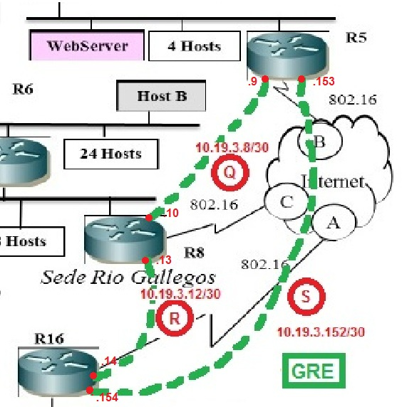

Utilizando el tutorial expuesto en la cátedra, se crearon túneles GRE para encapsular en la red las conexiones de los routers R5, R8 y R16 a Internet. En el diagrama anterior se puede observar el equivalente de la topología luego de implementar los túneles GRE. Gracias al mismo, se crea una conexión punto a punto entre R5 y R8, R8 y R16, R16 y R5.

Se exhibe a continuación, la configuración pertinente al protocolo GRE en los routers mencionados anteriormente:

**R5**

interface Tunnel10

ip address 10.19.3.9 255.255.255.252

tunnel source 133.143.1.1

tunnel destination 133.143.1.5

interface Tunnel20

ip address 10.19.3.153 255.255.255.252

tunnel source 133.143.1.1

tunnel destination 133.143.1.9

**R8**

interface Tunnel40

ip address 10.19.3.10 255.255.255.252

tunnel source 133.143.1.5

tunnel destination 133.143.1.1

interface Tunnel50

ip address 10.19.3.13 255.255.255.252

tunnel source 133.143.1.5

tunnel destination 133.143.1.9

**R16**

interface Tunnel70

ip address 10.19.3.154 255.255.255.252

tunnel source 133.143.1.9

tunnel destination 133.143.1.1

interface Tunnel80

ip address 10.19.3.14 255.255.255.252

tunnel source 133.143.1.9

tunnel destination 133.143.1.5

1. **Frame Relay**

Se intentó configurar Frame Relay usando 6 routers con las siguientes configuraciones de DLCI en cada uno:

**FR1**

|  |  |  |  |
| --- | --- | --- | --- |
| **Interface In** | **DLCI In** | **Interface Out** | **DLCI Out** |
| s0/0 | 21 | Serial0/1 | 211 |
| s0/0 | 21 | Serial0/2 | 211 |
| s0/0 | 23 | Serial0/1 | 231 |
| s0/0 | 23 | Serial0/2 | 231 |
| s0/1 | 122 | Serial0/0 | 21 |
| s0/1 | 322 | Serial0/0 | 23 |
| s0/2 | 126 | Serial0/0 | 21 |
| s0/2 | 326 | Serial0/0 | 23 |

**FR2**

|  |  |  |  |
| --- | --- | --- | --- |
| **Interface In** | **DLCI In** | **Interface Out** | **DLCI Out** |
| s0/0 | 211 | Serial0/1 | 212 |
| s0/0 | 231 | Serial0/1 | 232 |
| s0/1 | 126 | Serial0/0 | 122 |
| s0/1 | 326 | Serial0/0 | 322 |

**FR3**

|  |  |  |  |
| --- | --- | --- | --- |
| **Interface In** | **DLCI In** | **Interface Out** | **DLCI Out** |
| s0/0 | 13 | Serial0/1 | 133 |
| s0/0 | 12 | Serial0/1 | 123 |
| s0/1 | 214 | Serial0/0 | 12 |
| s0/1 | 314 | Serial0/0 | 13 |

**FR4**

|  |  |  |  |
| --- | --- | --- | --- |
| **Interface In** | **DLCI In** | **Interface Out** | **DLCI Out** |
| s0/0 | 133 | Serial0/1 | 134 |
| s0/0 | 133 | Serial0/2 | 134 |
| s0/0 | 123 | Serial0/1 | 124 |
| s0/0 | 123 | Serial0/2 | 124 |
| s0/1 | 216 | Serial0/0 | 214 |
| s0/1 | 316 | Serial0/0 | 314 |
| s0/1 | 236 | Serial0/2 | 234 |
| s0/2 | 215 | Serial0/0 | 214 |
| s0/2 | 315 | Serial0/0 | 314 |
| s0/2 | 325 | Serial0/1 | 324 |

**FR5**

|  |  |  |  |
| --- | --- | --- | --- |
| **Interface In** | **DLCI In** | **Interface Out** | **DLCI Out** |
| s0/0 | 31 | Serial0/1 | 315 |
| s0/0 | 31 | Serial0/2 | 315 |
| s0/0 | 32 | Serial0/1 | 325 |
| s0/0 | 32 | Serial0/2 | 325 |
| s0/1 | 134 | Serial0/0 | 31 |
| s0/1 | 124 | Serial0/2 | 125 |
| s0/1 | 234 | Serial0/0 | 32 |
| s0/2 | 136 | Serial0/0 | 31 |
| s0/2 | 236 | Serial0/0 | 32 |
| s0/2 | 216 | Serial0/1 | 215 |

**FR6**

|  |  |  |  |
| --- | --- | --- | --- |
| **Interface In** | **DLCI In** | **Interface Out** | **DLCI Out** |
| s0/0 | 211 | Serial0/2 | 216 |
| s0/0 | 211 | Serial0/3 | 216 |
| s0/0 | 231 | Serial0/2 | 236 |
| s0/0 | 231 | Serial0/3 | 236 |
| s0/1 | 212 | Serial0/2 | 216 |
| s0/1 | 212 | Serial0/3 | 216 |
| s0/1 | 232 | Serial0/2 | 236 |
| s0/1 | 232 | Serial0/3 | 236 |
| s0/2 | 124 | Serial0/0 | 126 |
| s0/2 | 124 | Serial0/1 | 126 |
| s0/2 | 134 | Serial0/3 | 136 |
| s0/2 | 324 | Serial0/0 | 326 |
| s0/2 | 324 | Serial0/1 | 326 |
| s0/3 | 315 | Serial0/2 | 126 |
| s0/3 | 325 | Serial0/0 | 326 |
| s0/3 | 325 | Serial0/1 | 326 |
| s0/3 | 125 | Serial0/0 | 126 |
| s0/3 | 125 | Serial0/1 | 126 |

Hubo problemas con FR3 ya que no cargaba la tabla de DLCI, por lo cual finalmente se decidió por usar un único Frame Relay donde todos los routers se conectan entre sí.

A continuación, se exhibe la configuración pertinente a Frame Relay implementada en cada uno de los routers conectados a la nube:

**R1**

interface serial1/0

no ip address

encapsulation frame-relay

interface serial1/0.1 point-to-point

ip address 172.143.0.65 255.255.255.252

frame-relay interface-dlci 112

interface serial1/0.2 point-to-point

ip address 172.143.0.69 255.255.255.252

frame-relay interface-dlci 113

**R12**

interface serial1/0

no ip address

encapsulation frame-relay

serial restart-delay 0

interface serial1/0.1 point-to-point

ip address 172.143.0.66 255.255.255.252

frame-relay interface-dlci 121

interface serial1/0.2 point-to-point

ip address 172.143.0.73 255.255.255.252

frame-relay interface-dlci 123

**R13**

interface serial1/0

no ip address

encapsulation frame-relay

serial restart-delay 0

interface serial1/0.1 point-to-point

ip address 172.143.0.70 255.255.255.252

frame-relay interface-dlci 131

interface serial1/0.2 point-to-point

ip address 172.143.0.74 255.255.255.252

frame-relay interface-dlci 132

1. **VRRP (Virtual Router Redundancy Protocol)**

VRRP es un protocolo de redundancia definido en el RFC 3768. El objetivo es mantener disponible una puerta de enlace para una determinada red. Para ello se define un router virtual y se configuran dos o más routers físicos, de los cuales solo uno va a realizar realmente el enrutamiento. Si el router físico falla o alguna de sus interfaces (sobre las cuales se aplica el protocolo) cae, se negocia mediante el traspaso de mensajes quien es el próximo router que toma el rol de maestro.

En el caso del presente trabajo, se aplicó VRRP en dos pares de routers, por un lado R3 y R4, y por el otro R9 y R10.

A continuación se muestra como se aplicó el protocolo en ambos casos.

**R3**

interface Ethernet0/0

description Red A - Trek

ip address 10.118.5.3 255.255.255.0

full-duplex

vrrp 10 description vrrp_lan_1

vrrp 10 priority 110

vrrp 10 timers advertise 15

vrrp 10 timers learn

vrrp 10 ip 10.118.5.5

vrrp 10 track 1 decrement 20

vrrp 10 track 2 decrement 20

no shut

interface Ethernet0/1

description Red C - Specialized

ip address 192.168.71.1 255.255.255.0

full-duplex

vrrp 11 description vrrp_lan_isp

vrrp 11 priority 110

vrrp 11 timers advertise 15

vrrp 11 timers learn

vrrp 11 ip 192.168.71.3

vrrp 11 track 1 decrement 20

vrrp 11 track 2 decrement 20

no shut

**R4**

interface Ethernet0/1

description Red A - Trek

ip address 10.118.5.4 255.255.255.0

full-duplex

vrrp 1 description vrrp_lan_1

vrrp 1 priority 100

vrrp 1 timers advertise 15

vrrp 1 timers learn

vrrp 1 ip 10.118.5.5

vrrp 1 track 1 decrement 20

vrrp 1 track 2 decrement 20

no shut

interface Ethernet0/0

description Red C - Specialized

ip address 192.168.71.2 255.255.255.0

full-duplex

vrrp 11 description vrrp_lan_isp

vrrp 11 priority 100

vrrp 11 timers advertise 15

vrrp 11 timers learn

vrrp 11 ip 192.168.71.3

vrrp 11 track 1 decrement 20

vrrp 11 track 2 decrement 20

no shut

**R9**

interface Ethernet1/1

description SW3 - Red H - Lapierre

ip address 10.19.3.131 255.255.255.240

speed auto

full-duplex

vrrp 10 description vrrp_lan_isp

vrrp 10 priority 100

vrrp 10 timers advertise 15

vrrp 10 timers learn

vrrp 10 ip 10.19.3.133

vrrp 10 track 1 decrement 20

vrrp 10 track 2 decrement 20

no shut

interface Ethernet1/0

description Link to L - Cannondale

ip address 10.19.3.65 255.255.255.224

full-duplex

speed auto

vrrp 11 description vrrp_lan_1

vrrp 11 priority 100

vrrp 11 timers advertise 15

vrrp 11 timers learn

vrrp 11 ip 10.19.3.67

no shut

**R10**

interface Ethernet1/2

description Link to SW3 - H, Lapierre

ip address 10.19.3.132 255.255.255.240

full-duplex

vrrp 10 description vrrp_lan_isp

vrrp 10 priority 110

vrrp 10 timers advertise 15

vrrp 10 timers learn

vrrp 10 ip 10.19.3.133

vrrp 10 track 1 decrement 20

vrrp 10 track 2 decrement 20

no shut

interface Ethernet1/0

description Link to SW4 - J, BH

ip address 10.19.2.5 255.255.255.128

full-duplex

no shut

interface Ethernet1/1

description Link to SW6 - L, Cannondale

ip address 10.19.3.66 255.255.255.224

full-duplex

vrrp 11 description vrrp_lan_1

vrrp 11 priority 110

vrrp 11 timers advertise 15

vrrp 11 timers learn

vrrp 11 ip 10.19.3.67

vrrp 11 track 1 decrement 20

vrrp 11 track 2 decrement 20

no shut

1. **DNS**

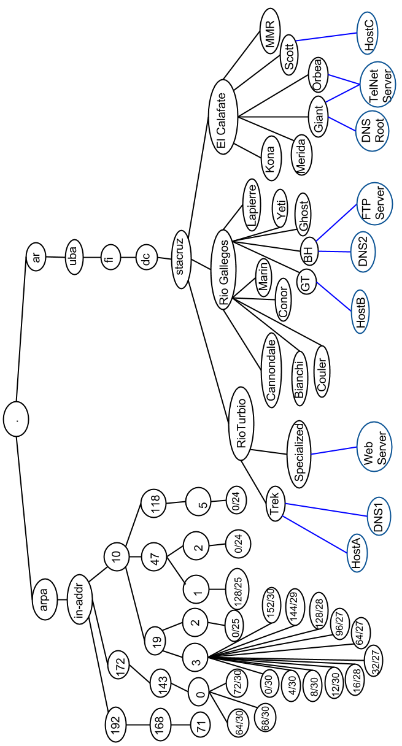

Existen tres servidores DNS y tres zonas:

* Rio Turbio
* Rio Gallegos
* El Calafate

Para obtener la ip asociado a un nombre (o viceversa), cada host realiza la solicitud a su servidor DNS local, que corresponde a la zona en la que se encuentre. A la sede Rio Turbio le corresponde el DNS 1 y a las sedes Rio Gallegos y El Calafate les corresponde el DNS 2.

Cuando un servidor DNS no conoce un nombre de dominio y posee el mismo dominio, este realiza una solicitud al DNS root que le responde con la dirección del otro servidor DNS para así consultar por la respuesta de la solicitud inicial, y de esta manera se resolvería la solicitud de forma iterativa.

El DNS Root está en la red Giant de la zona El Calafate con ip 10.47.1.131. Delega la autoridad en los restantes dos servidores de nivel dos:

- DNS1, en la red Trek de la zona Rio Turbio con ip 10.118.5.7, para la zona Rio Turbio.

- DNS2, en la red BH de la zona Rio Gallegos con ip 10.19.2.4, para el resto de las zonas.

|  |  |  |  |  |
| --- | --- | --- | --- | --- |
|  | **Componente** | **IP address** | **name** | **dns address** |
| **Rio Turbio** | Trek - 10.118.5.0/24 - (.trek.rioturbio.stacruz.dc.fi.uba.ar) | | | |
| R1 | .1 | r1 | r1.trek.rioturbio.stacruz.dc.fi.uba.ar |
| R2 | .2 | r2 | r2.trek.rioturbio.stacruz.dc.fi.uba.ar |
| R3 | .3 | r3 | r3.trek.rioturbio.stacruz.dc.fi.uba.ar |
| R4 | .4 | r4 | r4.trek.rioturbio.stacruz.dc.fi.uba.ar |
| **DNS1** | **10.118.5.7** | **ns1** | **ns1.trek.rioturbio.stacruz.dc.fi.uba.ar** |
| **HostA** | **10.118.5.6** | **hosta** | **hosta.trek.rioturbio.stacruz.dc.fi.uba.ar** |
| Specialized - 192.168.71.0/24 - (.specialized.rioturbio.stacruz.dc.fi.uba.ar) | | | |
| R3 | .1 | r3 | r3.specialized.rioturbio.stacruz.dc.fi.uba.ar |
| R4 | .2 | r4 | r4.specialized.rioturbio.stacruz.dc.fi.uba.ar |
| R5 | .4 | r5 | r5.specialized.rioturbio.stacruz.dc.fi.uba.ar |
| **WebServer** | **192.168.71.71** | **webserver** | **webserver.specialized.rioturbio.stacruz.dc.fi.uba.ar** |
| **Rio Gallegos** | GT - 10.19.3.32/27 - (.gt.riogallegos.stacruz.dc.fi.uba.ar) | | | |
| R6 | .33 | r6 | r6.gt.riogallegos.stacruz.dc.fi.uba.ar |
| R7 | .34 | r7 | r7.gt.riogallegos.stacruz.dc.fi.uba.ar |
| **HostB** | **10.19.3.35** | **hostb** | **hostb.gt.riogallegos.stacruz.dc.fi.uba.ar** |
| Lapierre - 10.19.3.128/28 - (.lapierre.riogallegos.stacruz.dc.fi.uba.ar) | | | |
| R7 | .129 | r7 | r7.lapierre.riogallegos.stacruz.dc.fi.uba.ar |
| R8 | .130 | r8 | r8.lapierre.riogallegos.stacruz.dc.fi.uba.ar |
| R9 | .131 | r9 | r9.lapierre.riogallegos.stacruz.dc.fi.uba.ar |
| R10 | .132 | r10 | r10.lapierre.riogallegos.stacruz.dc.fi.uba.ar |
| BH - 10.19.2.0/25 - (.bh.riogallegos.stacruz.dc.fi.uba.ar) | | | |
| **FTP Server** | **10.19.2.4** | **ftp** | **ftpserver.bh.riogallegos.stacruz.dc.fi.uba.ar** |
| R10 | .5 | r10 | r10.bh.riogallegos.stacruz.dc.fi.uba.ar |
| R11 | .2 | r11 | r11.bh.riogallegos.stacruz.dc.fi.uba.ar |
| R12 | .3 | r12 | r12.bh.riogallegos.stacruz.dc.fi.uba.ar |
| **Dns2** | **10.19.2.1** | **dns2** | **ns2.bh.riogallegos.stacruz.dc.fi.uba.ar** |
| Cannondale - 10.19.3.64/27 - (.cannondale.riogallegos.stacruz.dc.fi.uba.ar) | | | |
| R9 | .65 | r9 | r9.cannondale.riogallegos.stacruz.dc.fi.uba.ar |
| R10 | .66 | r10 | r10.cannondale.riogallegos.stacruz.dc.fi.uba.ar |
| R11 | .68 | r11 | r11.cannondale.riogallegos.stacruz.dc.fi.uba.ar |
| **El Calafate** | Orbea - 10.47.2.0/24 - (.orbea.elcalafate.stacruz.dc.fi.uba.ar) | | | |
| **TelServer** | **10.47.2.129** | **telserver** | **telserver.orbea.elcalafate.stacruz.dc.fi.uba.ar** |
| R14 | .1 | r14 | r14.orbea.elcalafate.stacruz.dc.fi.uba.ar |
| R15 | .2 | r15 | r15.orbea.elcalafate.stacruz.dc.fi.uba.ar |
| R16 | .3 | r16 | r16.orbea.elcalafate.stacruz.dc.fi.uba.ar |
| Giant - 10.47.1.128/26 - (.giant.elcalafate.stacruz.dc.fi.uba.ar) | | | |
| **TelServer** | **10.47.1.130** | **telserver** | **telserver.giant.elcalafate.stacruz.dc.fi.uba.ar** |
| **DNSroot** | **10.47.1.131** | **dnsroot** | **nsroot.giant.elcalafate.stacruz.dc.fi.uba.ar** |
| R9 | .129 | r9 | r9.giant.elcalafate.stacruz.dc.fi.uba.ar |
| Kona - 10.19.3.144/29 - (.kona.elcalafate.stacruz.dc.fi.uba.ar) | | | |
| R15 | .145 | r15 | r15.kona.elcalafate.stacruz.dc.fi.uba.ar |
| Merida - 10.19.3.16/28 - (.merida.elcalafate.stacruz.dc.fi.uba.ar) | | | |
| R15 | .17 | r15 | r15.merida.elcalafate.stacruz.dc.fi.uba.ar |
| Scott - 10.19.3.96/27 - (.scott.elcalafate.stacruz.dc.fi.uba.ar) | | | |
| R13 | .97 | r13 | r13.scott.elcalafate.stacruz.dc.fi.uba.ar |
| R14 | .98 | r14 | r14.scott.elcalafate.stacruz.dc.fi.uba.ar |
| **HostC** | **10.47.3.99** | **hostc** | **hostc.scott.elcalafate.stacruz.dc.fi.uba.ar** |
| **Frame-Relay** | Bianchi - 172.143.0.68/30 - (.bianchi.riogallegos.stacruz.dc.fi.uba.ar) | | | |
| R1 | .69 | r1 | r1.bianchi.riogallegos.stacruz.dc.fi.uba.ar |
| R13 | .70 | r13 | r13.bianchi.riogallegos.stacruz.dc.fi.uba.ar |
| Couler - 172.143.0.64/30 - (.couler.riogallegos.stacruz.dc.fi.uba.ar) | | | |
| R1 | .65 | r1 | r1.couler.riogallegos.stacruz.dc.fi.uba.ar |
| R12 | .66 | r12 | r12.couler.riogalledos.stacruz.dc.fi.uba.ar |
| Yeti - 172.143.0.72/30 - (.yeti.riogallegos.stacruz.dc.fi.uba.ar) | | | |
| R12 | .73 | r12 | r12.yeti.riogallegos.stacruz.dc.fi.uba.ar |
| R13 | .74 | r13 | r13.yeti.riogallegos.stacruz.dc.fi.uba.ar |
| **GRE** | Conor - 10.19.3.8/30 - (.conor.riogallegos.stacruz.dc.fi.uba.ar) | | | |
| R5 | .9 | r5 | r5.conor.riogallegos.stacruz.dc.fi.uba.ar |
| R8 | .10 | r8 | r8.conor.riogallegos.stacruz.dc.fi.uba.ar |
| Marin - 10.19.3.12/30 - (.marin.riogallegos.stacruz.dc.fi.uba.ar) | | | |
| R8 | .13 | r8 | r8.marin.riogallegos.stacruz.dc.fi.uba.ar |
| R16 | .14 | r16 | r16.marin.riogallegos.stacruz.dc.fi.uba.ar |
| Ghost - 10.19.3.152/30 - (.ghost.riogallegos.stacruz.dc.fi.uba.ar) | | | |
| R5 | .153 | r5 | r5.ghost.riogallegos.stacruz.dc.fi.uba.ar |
| R16 | .154 | r16 | r16.ghost.riogallegos.stacruz.dc.fi.uba.ar |
| **Enlaces** | Raleigh - 10.19.3.0/30 - (.raleigh.riogallegos.stacruz.dc.fi.uba.ar) | | | |
| R2 | .1 | r2 | r2.raleigh.riogallegos.stacruz.dc.fi.uba.ar |
| R6 | .2 | r6 | r6.raleigh.riogallegos.stacruz.dc.fi.uba.ar |
| MMR - 10.19.3.4/30 - (.mmr.elcalafate.stacruz.dc.fi.uba.ar) | | | |
| R11 | .5 | r11 | r11.mmr.elcalafate.stacruz.dc.fi.uba.ar |
| R13 | .6 | r13 | r13.mmr.elcalafate.stacruz.dc.fi.uba.ar |